Executive Summary
In present state, rIXD Receive Dock teams currently utilize IDRT to virtually move pallets shipped from nIXD from the shipment manifest to a drop zone on site, which also confirms which pallets physically arrived on site and provides improved visibility for all transshipped freight being processed through the facility. However, IDRT is currently unable to take the paX labels applied to New Vendor Freight (NVF) pallets via IMTP as inputs. In Week 14, NVF comprised 69.17% of pid carton volume and 87.2% of pallet receive volume in rIXD (Appendix A).

Indirect Role Conversion Pilot
From Week 49 to Week 3, a pilot was conducted at SWF2 to modify to standard work for waterspiders on Outbound Dock. Waterspiders were directed to utilize a hand scanner to move pallets to staging areas using the “Move Container” function, which changed their labor tracking from Transfer Out Dock -> EOL Waterspider (indirect) to Transfer Out Dock -> Pallet Movement (direct). Modifying their labor tracking in this manner gave Outbound Dock leadership visibility into associate rates and a mechanism for entering idle time feedbacks for applicable associates.
Rates for these associates increased from by 57.7% during the pilot (Appendix B). Additionally during the same time frame, the following Quality wins materialized:
- Dwelling Inventory Over Threshold (DIOT) was reduced by 77.9% (Appendix C).
- Inventory in Odd Locations (IOL) Over Threshold was reduced by 96.2% (Appendix D).
- Unexpected Container Overages (UCO) was reduced by 36.8% (Appendix E).

Projected Lift

Revised Inbound Dock Waterspider Standard Work

Required Change
To roll out revised standard work that will allow for Receive Dock waterspider headcount to be converted to direct a direct function,

Appendix
Appendix A: rIXD Big Box Receive Data Week 14
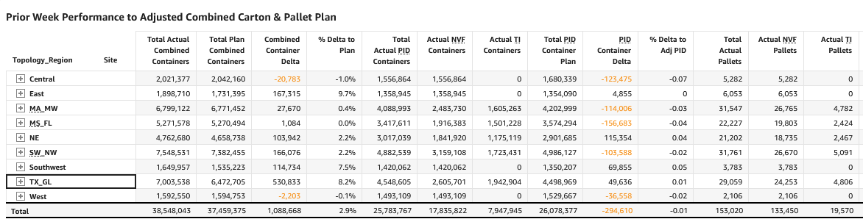
Appendix B: SWF2 Pallet Movement Rates Week 49 to Week 3

Appendix C: SWF2 DIOT Week 49 to Week 3

Appendix D: SWF2 IOL Over Threshold Week 49 to Week 3

Appendix C: Inbound Dock Waterspider MSMs reported by rIXD sites October 2024.

